**Social Media Analysis**

**Making Products Count:**

**Data Science for Product Managers (Fall 2023)**

**Final Project Report**

Angela Yang,

Dollaya Hirunyasiri,

Juan Puentes,

Qingyuan Zheng,

Skylar Li

**December 8, 2023**

# 

# Table of content

**Table of content 2**

**Executive summary 3**

**Context 3**

Diabetes as a condition 3

Target customers 4

Dataset 4

Relevance of Social Media Analysis 4

Problem statement 4

**Data preparation 5**

Data preparation 5

Investigation on Sentiment 5

**General CGM analysis 7**

Question 1: What are patient expectations of CGMs? 7

Question 2: What benefits are most important to diabetic patients? 7

Question 3: What unmet needs do patients have related to CGMs? 8

Question 4: What are patient knowledge gaps with CGMs? 8

**CGM Product-related analysis 9**

Question 5: What is the overall sentiment of the two brands? 9

Modeling 9

Results 10

Analysis of Sentiment Trends Across Brands 10

Overview of Adjective Usage Across the Two Brands 12

Question 6: What is the sentiment on product features of the two products? 12

Modeling 12

Results 12

Question 7: What are praises & complaints of the two products? 14

Modeling 14

Results 15

Dexcom: Praise 16

Dexcom: Complaint 16

FreeStyle Libre: Praise 16

FreeStyle Libre: Complaint 17

Question 8: What other improvement opportunities exist for both Dexcom and FreeStyle Libre? 17

Modeling 17

Results 17

**Recommendation 19**

Dexcom 19

FreeStyle Libre 19

**Contribution 20**

# 

# Executive summary

This study examines the perspectives of Type 1 diabetes patients on two Continuous Glucose Monitoring (CGM) brands, Dexcom and Freestyle Libre, based on social media data from 2021-2022, utilizing NLP for analysis.

In the general CGM assessment, customers expect these products to bring more ease to their daily routines. However, there are unfulfilled needs like temperature resilience in devices and improved CGM alerts, alongside a lack of understanding about CGM's integration with insulin pumps.

In terms of specific brand insights and feedback, Dexcom and FreeStyle Libre are both acclaimed for enhancing daily life convenience by aiding in glucose level monitoring. However, they are both criticized for causing skin irritation and not being covered by insurance.

Focusing on each brand, Dexcom is particularly noted for its accurate insulin dosage management and exceptional post-sale support, but faces criticism for its high pricing and issues with software integration.

Conversely, Freestyle Libre is appreciated for its affordability and user-friendly app, yet it occasionally receives complaints about the accuracy of its tracking system.

We advise both brands to further develop their strong points while addressing these identified areas of improvement. For Dexcom, this involves expanding smartphone pairings or app integrations, devising a pricing strategy to increase accessibility for a wider audience, and seeking collaborations with insurance companies. As for FreeStyle Libre, they should focus on integrating with widely-used lifestyle apps, investing in the research and development of gentler sensors for the skin, and enhancing both the speed and accuracy of their product's readings.

# Context

## Diabetes as a condition

Diabetes is a group of diseases that affect how the body uses glucose (sugar in blood). Glucose is an important source of energy for the brain and for the cells that build muscle and tissue. Diabetes results from either the pancreas not producing enough insulin or the cells of the body not responding properly to the insulin produced. This led to an excess of sugar in blood which can have extreme detrimental effects on health causing problems in: Eyes, foot, heart, kidneys, nerves, gums and make patients more prone to certain types of cancer.

## Target customers

Type 1 diabetes is one of the most common chronic childhood diseases in the United States, accounting for nearly 98% of all diabetes cases in children aged 10 or younger. People with type 1 diabetes do not produce enough insulin to properly control their blood glucose levels. To maintain their health, these patients must measure their glucose levels several times a day for their entire lives. In response to this need, Continuous Glucose Monitoring (CGM) systems have been developed.[1]

## 

## Dataset

The dataset contains over 37,000 records of CGM-related comments from various sources, including Reddit, Facebook, Instagram, Twitter, and others. The most important variables include the title of the post, its text content, and a sentiment variable that was pre-existing in the dataset.

## Relevance of Social Media Analysis

According to IBM, social media natural language analysis can help businesses to refine their products by identifying real-world instances where there's room for enhancement.[2] This type of analysis is key for spotting emerging trends linked to brands, understanding customer sentiments towards products and services, identifying features that consumers value most, and keeping an eye on competitors' activities.

## Problem statement

Two of the most popular options for CGM are Dexcom and FreeStyle Libre, both options provide slightly different characteristics and experiences. In this report, we will identify some of those differences using natural language processing and guiding us by orientational questions. We have divided the study into two big sections.

**1. Customer Expectations and Knowledge Gaps**

* What are customer expectations?
* What benefits are most important to diabetic patients?
* What unmet needs do patients have related to CGMs (something patients want but are not getting)?
* What are customer knowledge gaps?

**2. Brand Perception and Feedback**

* What is the overall sentiment of the two products?
* What is the sentiment on product features of the two products?
* What are praises & complaints of the two products?

# Data preparation

## Data preparation

In data preparation, we reviewed missing values, finding minimal need for imputation due to mostly non-null objective variables. We analyzed the sentiment variable's distribution through plotting, followed by examining a text sample for structural insights. The text was then processed by converting to lowercase, removing punctuation with regular expressions, and filtering out stop words and frequent words. Finally, we prepared lemmatized and stemmed text versions, setting the stage for preliminary exploratory data analysis.

## Investigation on *Sentiment*

The dataset has provided us the *Sentiment* of social media post text, including positive, negative, mixed, and Neutral sentiments. However, since we were not aware of its derived mechanism, additional investigation was applied.

We used VADER, a rule-based sentiment analysis tool, as well as ChatGPT 4 to evaluate a random sample of cleaned text (sample size 100), and to determine if we should use VADER-generated sentiment or *Sentiment* in the dataset.

First, we randomly sampled 100 pieces of cleaned texts. Then we provided the context to ChatGPT, which were social media posts about diabetes and CGM topics. We then instructed it to evaluate the text sentiment and generate only ‘Positive’, ‘Negative,’ or ‘Neutral’ as response. By prompting it to evaluate text one at a time, we eventually gathered 100 responses. We used these responses as correct benchmarks, for ChatGPT 4 was a capable large language model.

For VADER, we categorized sentiment using compound score, and sentiments were defined as: negative: compound score <= -0.05, -0.05 < neutral < 0.05, and positive >= 0.05.

Below we have attached the comparison table.

| N = 100 | Provided *Sentiment* | VADER Sentiment |
| --- | --- | --- |
| accuracy | 61% | 36% |
| Contradictory categorization* | 6% | 6% |

*\*contradictory categorization refers to having opposite categorization with ChatGPT 4 generated answers, which could be more problematic, e.g. positive vs. negative and vice versa. Neutral sentiment does not apply here.*

In the comparison, the provided *Sentiment* has a higher accuracy regarding the categorization generated by ChatGPT 4. Both methods have 6% contradictory categorization.

Below we have also visualized the sentiment composition of each categorization method.

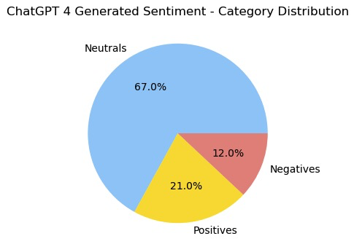

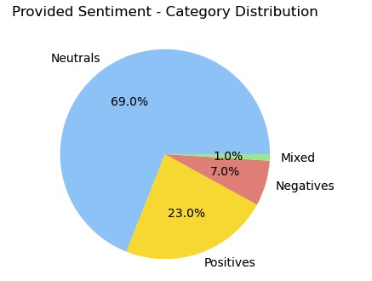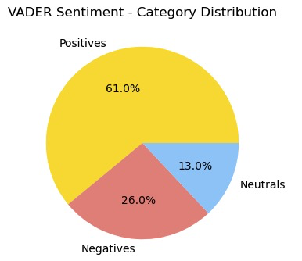

The majority of sampled text was ‘Neutral’ sentiment, and ‘Positive’, and with a minority of negative sentiment, according to ChatGPT 4. The provided sentiment distribution was similar to that of ChatGPT 4 provided answer, while VADER categorized the majority as ‘Positive.’ For example, VADER would categorize this piece of text as having positive sentiment: *“i feel like an app where i could just quick order things would be amazing rather than sitting on the phone for an hour just to get dexcom supplies mailed to me”.* The other two categorized it as neutral sentiment. We also looked up the text column and we considered the nature of this dataset, which was about social listening on diabetic-realated topics, was discussion-based and many users were looking for advice. In that sense, having neutral sentiment as the majority was more practical. Based on this investigation, we would use the provided *Sentiment* for further analysis.

# General CGM analysis

## Question 1: What are patient expectations of CGMs?

To investigate patients' expectations, we listed a few key words, such as “expect”, “hope”, ”anticipate”, etc., so that we were able to trace those words and focus on what was coming after them.

We used n-grams (4-grams and 8-grams) on each piece of text, and kept those that started with those keywords. The reason why we used many-grams (e.g. 8-grams), was because we observed in the text that patients usually didn’t express their expectation until many words after they said the keyword. For example, a patient posted: “...The best i can *hope* for now is to keep my blood sugar in check at ALL TIMES…” In this post, we identified their expectation as ‘keep’ and ’‘check’, and they appeared at least 5 words after *hope.* After n-grams technique was conducted, we then removed frequent words that were irrelevant in the context. Our finding was visualized in a word cloud below.

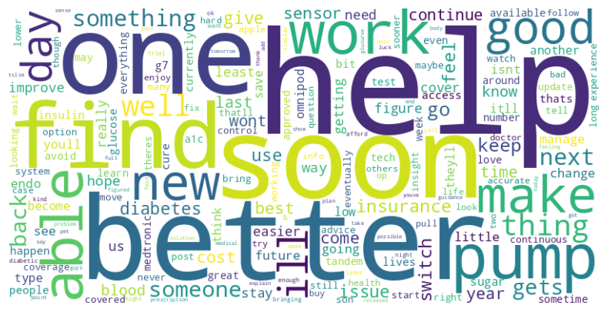

The most prominent words are ‘help’, ‘better’, ‘find’, ‘able’, ‘work’, etc. We interpreted those words as patients generally **seeking help and improving their life using CGMs**. And we also find clues in the dataset that some say. ‘I’m hoping something just works’ and ‘hope you are doing better.’

## Question 2: What benefits are most important to diabetic patients?

Our analysis utilized the most frequent trigrams to distill the main ideas about the benefits of CGM devices. A standout finding is that **users prioritize control over their blood sugar levels**. Features catering to this need emerging are considered most important. Many users have noted the devices' capability to provide updates every 5 minutes. This frequent monitoring is perceived as extremely useful, though it can sometimes be seen as annoying or overwhelming.

Another significant trigram points to **the appreciation of the closed-loop system**. As discussed earlier, these systems function akin to an artificial pancreas. The prevailing sentiment among users is one of gratitude, with many expressing positive views. They appreciate the relief from the constant need to monitor glucose levels and administer insulin injections.

A third notable benefit is the device's portability. **Several users report a preference for smaller devices**, as it eases their daily lives and allows them to forget they are wearing the device, highlighting its unobtrusiveness as a positive aspect.

## Question 3: What unmet needs do patients have related to CGMs?

By filtering trigrams with words related to 'desire,' we uncovered significant narratives. For instance, users have expressed a need for these systems to be more **temperature-resistant and less sensitive to placement**, since they want more flexibility at the time to locate the device in a non-visible part of their bodies.

There's also a call for **improvements for CGM notifications**, which can sometimes be overwhelming. Users are looking for ways to better control and customize these alerts and have selected moments of peace.

The analysis also highlights user concerns about **limited support for Android devices** and the slow performance of the app, particularly when pairing new devices.

Another emerging desire is for **increased memory capacity** in these devices.

## Question 4: What are patient knowledge gaps with CGMs?

The way that we approached patient knowledge gaps was to look up the *title* column. There were 1601 original posts with titles that included either ‘?’, a question mark, or ‘question’ keyword. Through the word distribution in *title*, we could develop a reliable understanding of patient knowledge gaps. Below is the word cloud generated from *title*.

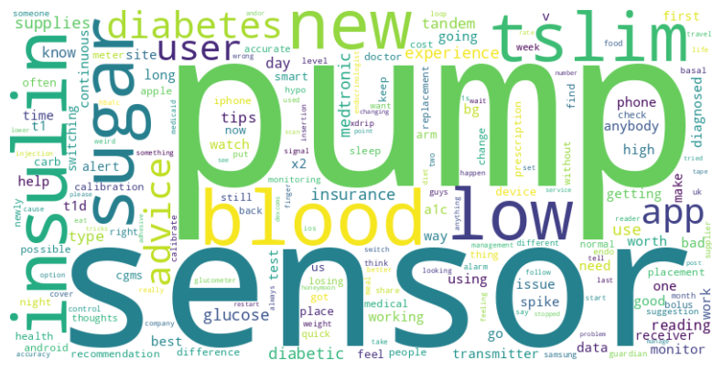

Below is the bar graph on the top ten frequent words.

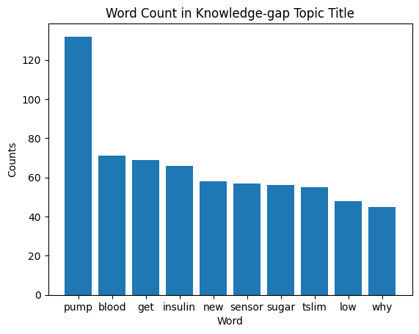

The word ‘pump’ was the most prominent of all. It is not only the top word, but also the word ‘tslim’ is an insulin pump brand as well. However, the CGM was a monitoring device, and the pump was not a part of it, so it seemingly should not show up this frequently in CGM related topics. We researched on the topic and developed a better understanding of the subject matter. It turned out that an insulin pump and a CGM worked together as a combo. An insulin pump would deliver insulin based on the readings of CGM, so together they mimic an artificial pancreas. While an integrated system has not yet become the mainstream, an insulin pump was a necessity. In that sense, **CGM companies could provide services to better address pump-related problems**.

Another observation was based on the dataset itself, given the source of information was from popular social media platforms, an older generation may not be aware of this advanced and complex technology. Therefore companies could find a channel to reach the older population, who had a higher percentage population with diabetes and could benefit from this technology.

# CGM Product-related analysis

## Question 5: What is the overall sentiment of the two brands?

### Modeling

| **Step** | **Purpose** | **Model/Method** |
| --- | --- | --- |
| Step 1: original sentiment analysis | Show the general user attitude | Pie chart -proportion |
| Step 2: original sentiment tendency | Show the user attitude changing over time | Plot chart tendency line |
| Step 3: compare with our own sentiment analysis | Check the accuracy of original dataset | NLTK's sentiment intensity analyzer |
| Step 4: conduct negative and positive adj words proportion for two brands | Estimate the user attitude from adj words usage | Pos Tagging  Textblob |

### Results

*General sentiment*

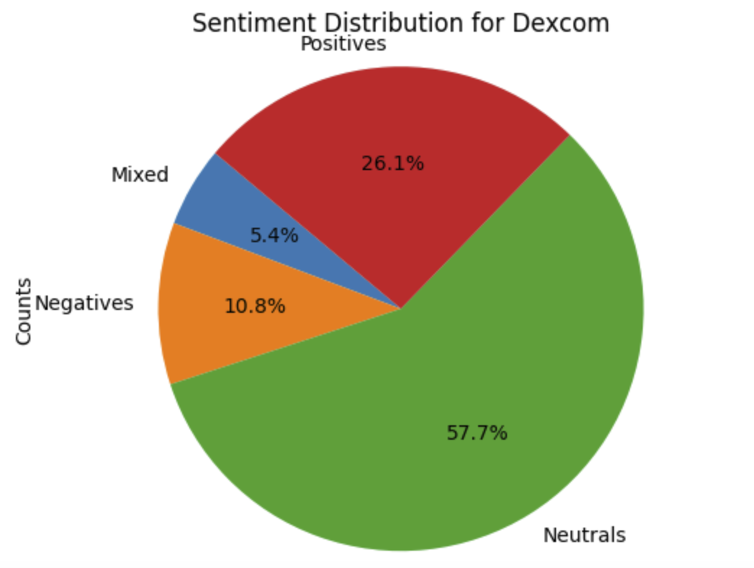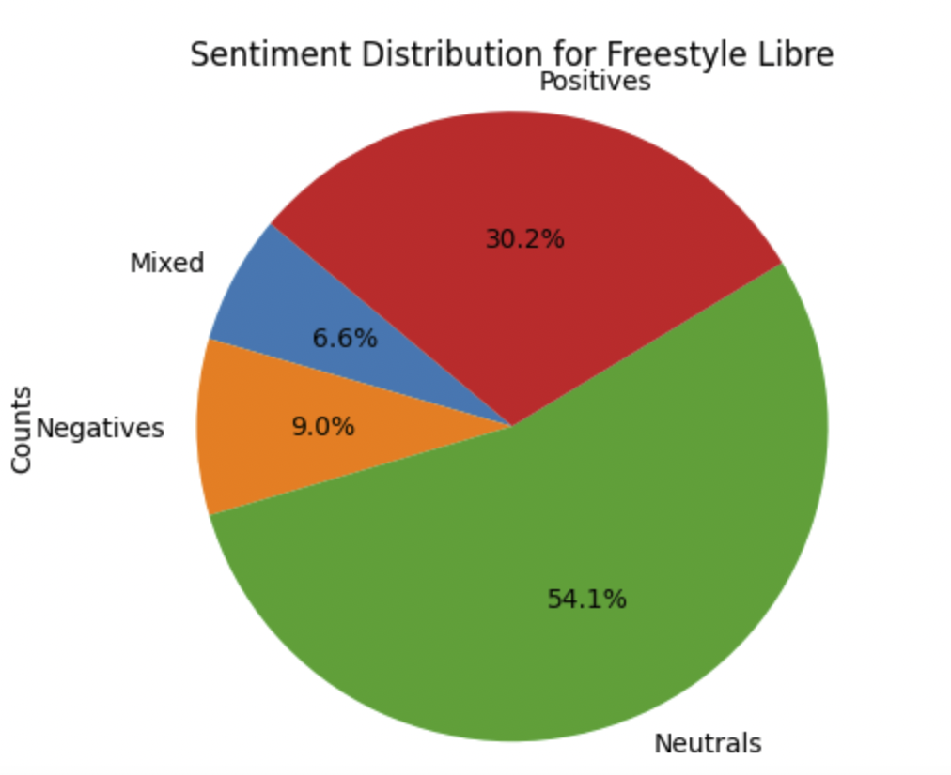

Generally, the user attitude for the two brands are close, but performing slightly better for FreeStyle Libre than Dexcom.

#### Analysis of Sentiment Trends Across Brands

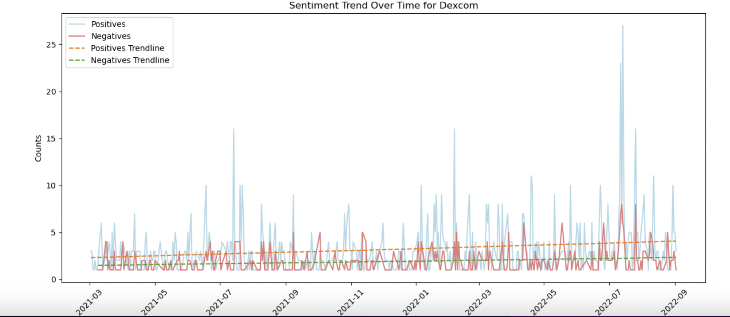

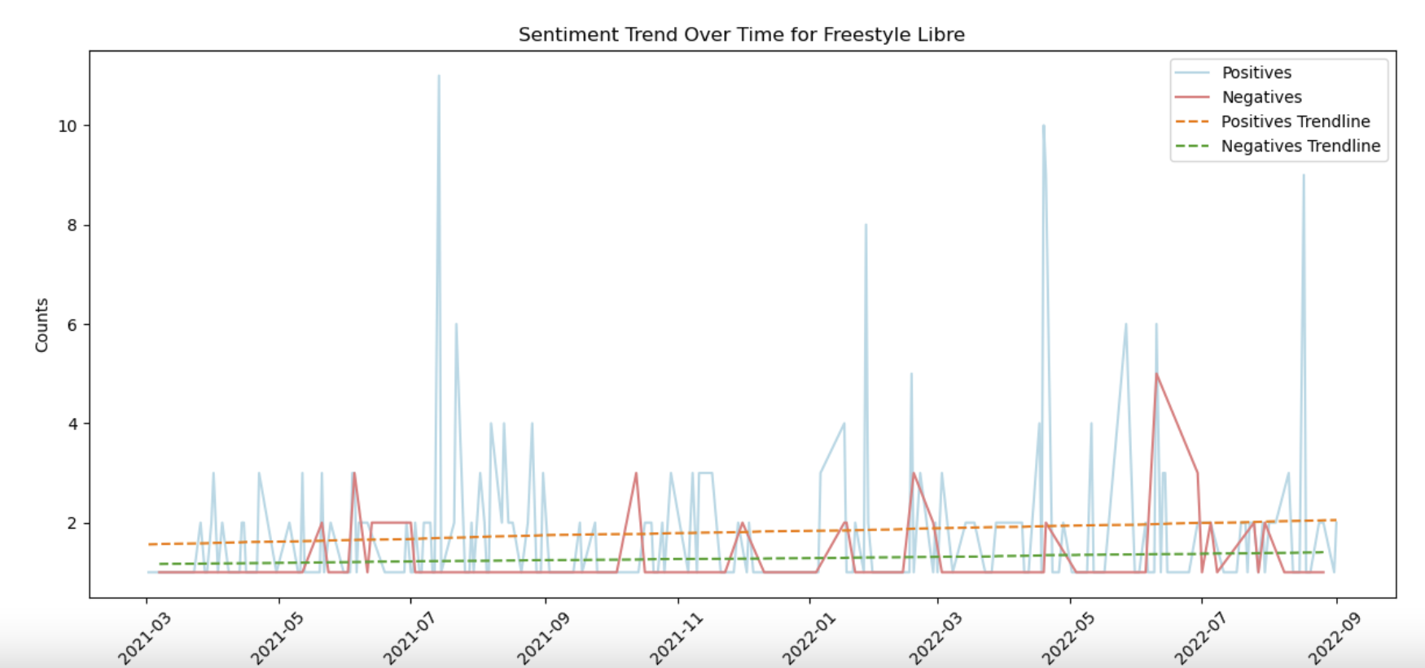

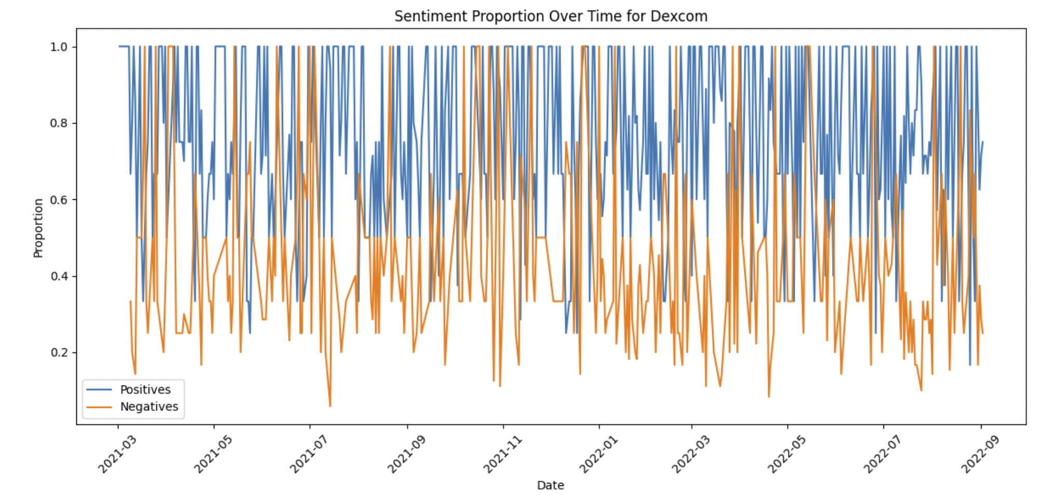

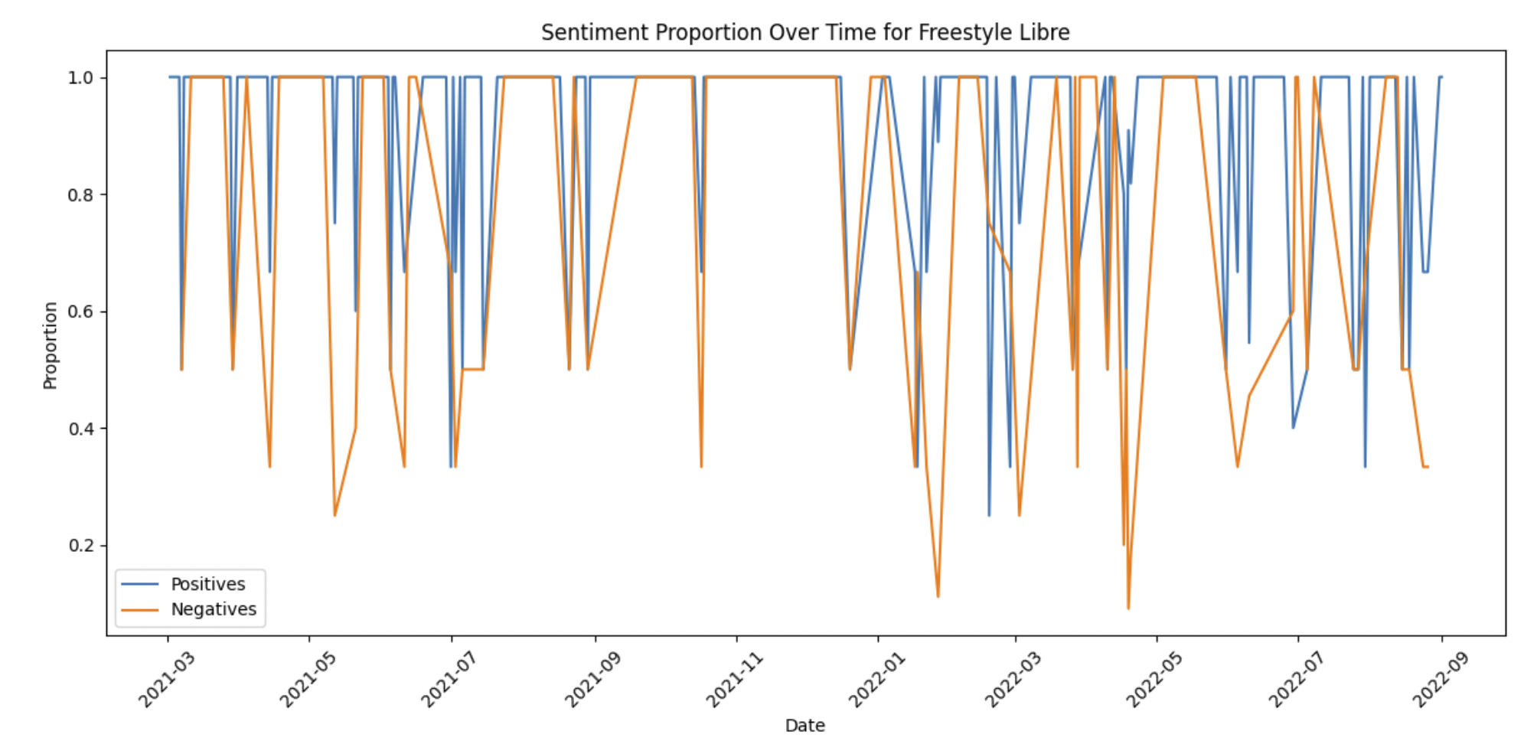

From March 2021 to September 2022, there's been an upward trend in both positive and negative feedback for both brands. Additionally, the ratio of positive to negative comments has remained consistent over this time frame. **This suggests that user sentiments and attitudes towards the two brands have remained stable throughout 2021 and 2022.**

#### Overview of Adjective Usage Across the Two Brands

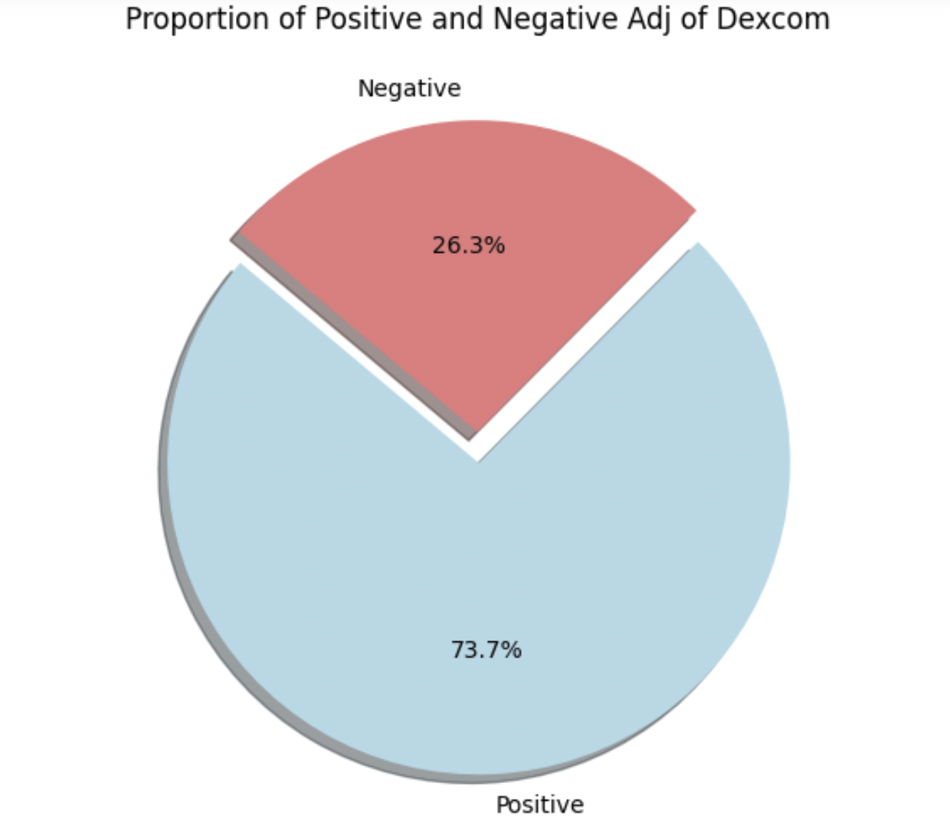 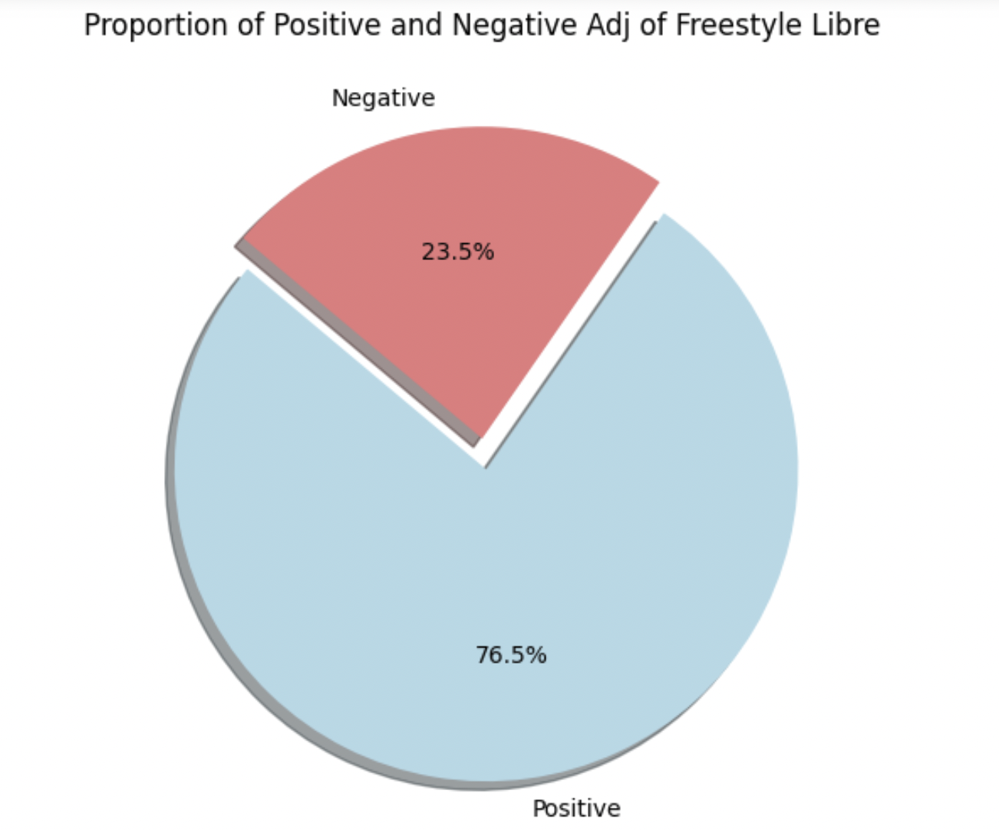

Users tend to use slightly more positive adjectives when describing FreeStyle Libre.

## Question 6: What is the sentiment on product features of the two products?

### Modeling

| **Step** | **Result** |
| --- | --- |
| Step 1: We separated each brand's feedback message with the cleaned text column. | * Dexcom data * FreeStyle Libre data |
| Step 2: Run the Pos tagging to find the most common phrase combo in   * (Adjective, noun) * (Adjective, noun, noun) * (Adverb, adjective, noun) | * Words combo and frequency |
| Step 3: Extract product features based on the frequency and accuracy of the word combo | * Product features |

### Results

Dexcom's highlighted features include its

1. **advanced sensors and transmitters** that provide **accurate, real-time glucose monitoring in the interstitial fluid**.
2. It is also well-integrated with **insulin pumps**, forming a comprehensive loop system.
3. It offers seamless **app compatibility with iPhone and Apple Watch**.

Positive customer feedback focuses on its excellent control quality, dependable charging system, and precise insulin dosage management. However, there are negative sentiments regarding its high cost and general lack of insurance coverage.

Conversely, FreeStyle Libre is recognized for its

1. effective glucose monitoring capabilities
2. easy-to-use scan-able sensor
3. compatibility with smart devices via FreeStyle Libre App

Users positively note its user-friendliness and more affordable pricing. Nevertheless, it faces criticism for the adhesive's limited durability and, similar to Dexcom, a lack of insurance coverage.

| Keywords extraction | Function | Quality | Pricing |
| --- | --- | --- | --- |
| Dexcom | new sensor  medtronic pump  tandem pump  insulin pump  interstitial fluid  sensors transmitters  continuous glucose monitor  apple watch dexcom  blood sugar control  glucose monitoring system  dexcom app phone  iphone apple watch  tslim dexcom combo  loop system | Good control  Durable medical  Include much insulin | Expansive product,  insurance won't cover |
| FreeStyle Libre | skin tac  free brace  interstitial glucose)  glucose monitoring)  scan sensor  Glucose meter  diet exercise  scan phone  ultimate guide  knee brace  prior authorization  FreeStyle libre app  FreeStyle libre system)  continuous glucose monitor  glucose monitoring device  libre sensor arm  FreeStyle libre software  monitoring apple watch | low carb  much insulin  good thing  easy use  injury persistent pain | insurance wont cover |

## Question 7: What are praises & complaints of the two products?

### Modeling

| **Step** | **Result** |
| --- | --- |
| Step 1: We classified customer feedback (Sound Bite Text Column) for each brand. | * Dexcom * FreeStyle Libre * Others |
| Step 2: We separated each brand's feedback into distinct sentiment categories. | * Dexcom Positive * Dexcom Negative * FreeStyle Libre Positive * FreeStyle Libre Negative * Others |
| Step 3: We utilized logistic regression to pinpoint the top 30 influential features in each sentiment category, ranking them based on their coefficients.  **Measurement metric**  The model's accuracy stands at 0.80. We opted for accuracy as our metric of choice instead of precision, recall, and F1 score, because in a multi-class logistic regression model, these metrics need individual calculations for each class followed by an average. To simplify the process, we decided to use accuracy. | * **Dexcom negative:** hate, suck, cant, painful, expensive, *(list go on…)* * **Dexcom positive:** g6, switched, tandem, omnipod, love, *(list go on…)* * **FreeStyle negative:** reader, knee, sensor, feature, scan, *(list go on…)* * **FreeStyle positive:** 14, use, glucose, love, abbot, *(list go on…)* |
| Step 4: We randomly chose five pieces of feedback, starting with the primary feature of the given classification, to determine if they provide specific insights about the brand rather than irrelevant comments. If the randomly selected feedback does not yield meaningful information, we proceed to analyze the second feature. This process is repeated until we gather a few features accompanied by comments that accurately reflect the sentiment associated with the brand. | * **Dexcom negative:** Expensive, Painful, Complication & app * **Dexcom positive:** Combo, Free, Reliable * **FreeStyle negative:** Skin, (In)Accurate * **FreeStyle positive:** Glucose, Track |
| Step 5: we conducted cross-validation by checking if the same features had a higher or lower occurrence in paired comparisons. For instance, if the top five features of 'dexcom negative' are hate, suck, cant, painful, and expensive, we compared their frequency in 'FreeStyle Libre negative' to gauge their prevalence. | In the primary comparison, each feature is significantly more common than in its corresponding paired analysis. For instance, the term 'Tslim' within the Dexcom Positive category constitutes 11.02% of the total mentions in that sentiment group (509 comments out of 4,617 total feedback), whereas in the context of FreeStyle, 'Tslim' is mentioned far less, making up only 0.07%. (1 comment out of 1,354 of total feedback) |

### Results

Based on selected features for each brand, both Dexcom and FreeStyle Libre are praised for enhancing customer convenience in daily life (Tslim, Exercise, and Track).

Both brands, however, face criticism due to skin-related side effects (Skin and Painful).

Regarding distinct aspects, Dexcom is particularly acclaimed for its post-sale support (Free), but it also faces criticism for its high pricing (Expensive) and issues with software integration (Complication). On the other hand, FreeStyle Libre is sometimes perceived as having inaccuracies in its tracking system results. (Track)

|  | Positive | Negative |
| --- | --- | --- |
| Dexcom | * Tslim * Free | * Expensive * Painful * Complication |
| FreeStyle Libre | * Exercise * Track | * Skin * (In)Accurate |

#### Dexcom: Praise

* **tslim**: Combination of Continuous Glucose Monitor and Insulin Pump
  + *Customer:* ***“the dexcom/tslim with control iq was my best combo*** *and there are more improvements coming later this year for this equipment.”*
* **Free** replacement when something isn’t functioning as expected**:** 
  + *Customer:* ***“i will say the dexcom response for putting in tickets has been great****. i’m so glad they’ll replace a sensor for free.”*

#### 

#### Dexcom: Complaint

* **Expensive**
* *Customer: “but until a company rep calls and helps me figure this crap out, i’m not going near it. for me,* ***the dexcom g6 was an expensive failure.”***
* **Painful** when putting on the skin
  + *Customer: “****as for the dexcom being painful,*** *i'm not entirely sure why its painful from what he tells me no matter where he puts it,* ***it's painful to the point where the can't/won't touch the area for days at a time.*** *he also told me that when he gets used to it being in that spot he has to move it and then the process starts all over again.”*
* **Complication** when integrating with other software applications
  + *Customer: “*i have an apple watch 3, and **have a dexcom complication,** and tbh, it kinda sucks. pretty much always shows a "--" unless i tap on it, then takes time to get the actual reading from the cgm/phone.”

#### FreeStyle Libre: Praise

* Making **Exercise** Possible for Diabetic Customers
  + *Customer: “i recommend getting a continuous glucose monitor so* ***you can see how your exercise is affecting your numbers in real time.*** *i use the free style libre but there are other options. i found when i go on really long hikes i will get very low glucose and i have to eat something high carb to refuel.”*
* **Tracking** feature
* *Customer: “****it’s worth the tracking to feel good!*** *it’s so nice to just scan that little beauty with my iphone* ***instead of pricking my fingers 5+ times a day.*** *my fingers thank me!!”*

#### FreeStyle Libre: Complaint

* **Skin** rashes, stemming from the necessity of attaching the equipment directly to the skin.
* *Customer: “****my FreeStyle libre sensors have been causing incredible rashes.*** *for about two years now i've carefully placed a physical bandage between the sensor and my skin, as well as over the sensor to hold it there for two weeks. does anyone have a better solution than this?”*
* **(In)accurate**
  + **my cgm (FreeStyle libre 3) is constantly 20 mg/dl too high** it’s annoying…ruining my average (**the other cgm i had before were accurate**)

## Question 8: What other improvement opportunities exist for both Dexcom and FreeStyle Libre?

### Modeling

| **Step** | **Purpose** | **Model/Method** |
| --- | --- | --- |
| Step 1: filter texts with negative keywords made by topic modeling just for negative tag text. | Identify negative comments for improvement | Topic Modeling, Word Cloud |
| Step 2: Identify   1. Bad experiences 2. Product suggestion   from the filtered texts containing . | Generate most symbolic negative sentence topic | Chatgpt |

### Results

Negative topic about dexcom

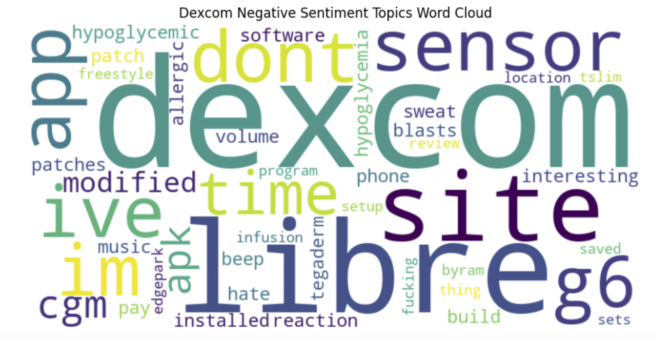

Negative topic about FreeStyle Libre

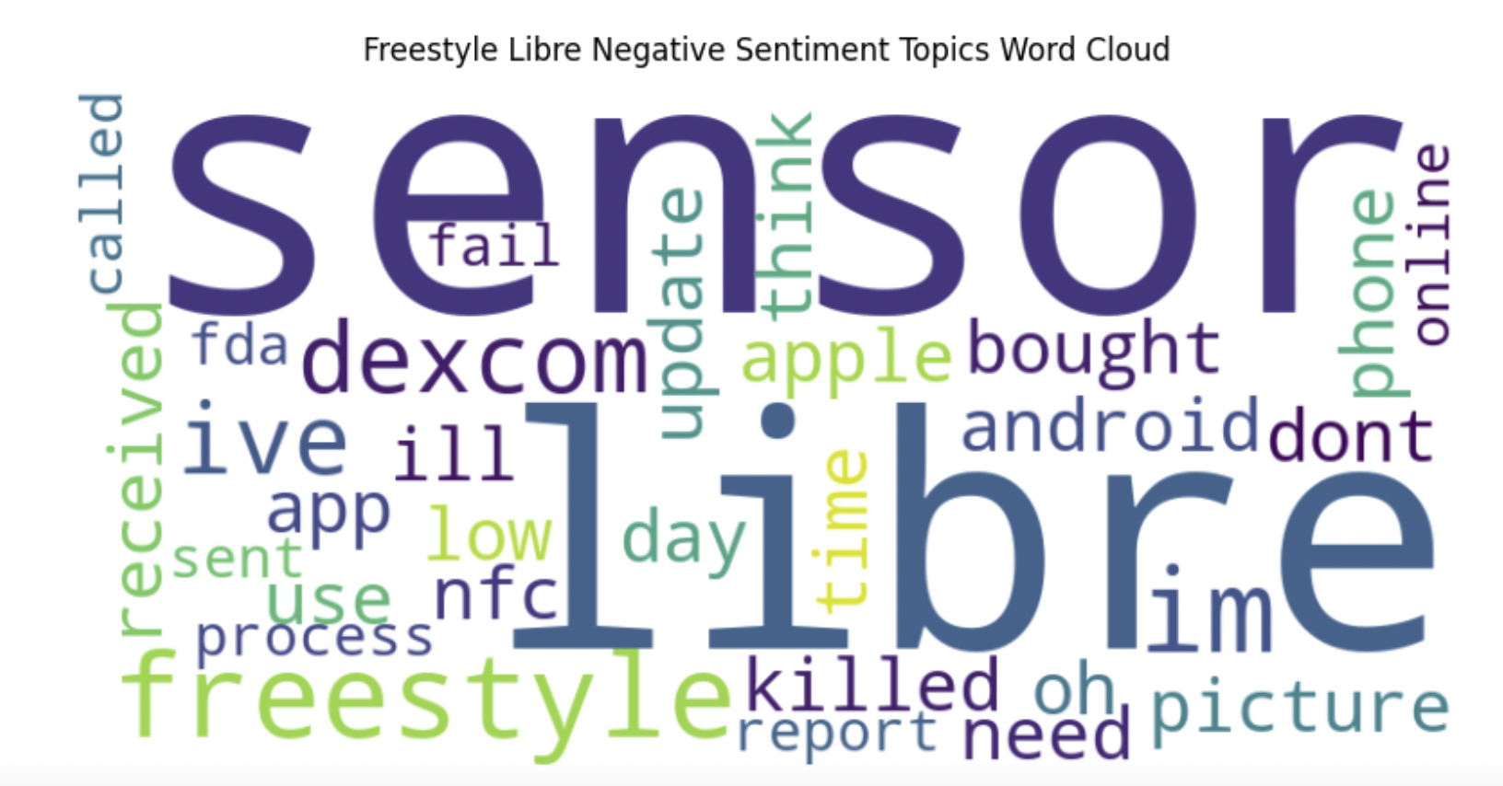

| **Negative Topics** | | |
| --- | --- | --- |
|  | Dexcom | FreeStyle Libre |
| Negative Topics | 'time', 'interesting', 'reaction', 'hate', 'allergic',, 'saved'. | 'apple', 'android', 'low', 'killed', 'update', 'time', 'fail', 'sent'. |
| Generated sentence Topics | * **Durability and Medicare Coverage:** Noted for its durability, Dexcom's equipment is, however, not covered by Medicare. * **Adhesive Problems:** To achieve better performance, users have opted for alternative adhesive products. * **Three-Week Reliability Limit:** Users report reliability issues with Dexcom devices after three weeks. * **Platform-Specific Challenges:** Android users face more issues compared to iOS users. | * **Performance Issues:** Slow functioning of the product. * **Customer Support:** Lack of effective support. * Not accurate reading results. |
| Suggestion | This user's suggestion is to try using a Dexcom G6 on the upper chest area for more comfort than originally thought. They suggest using it on the arms as it is the least intrusive. They recommend Android for a few options, but can't guarantee the answer after modifications. Additionally, they have noted that their Dexcom has been acting up lately around day 678. | This thread is discussing which continuous glucose monitor (CGM) to use and the experiences users have had with different types. Most users seem to prefer the Dexcom G6 over the Freestyle Libre, citing better accuracy and customer support. Others have had success with the Freestyle Libre 1 and 2, but also noted issues with reliability. Overall, users suggest seeking advice from your doctor and researching different CGMs to make an educated decision. |

# Recommendation

Based on the analysis, Dexcom and FreeStyle Libre could improve their products in several ways:

## Dexcom

1. Implement **additional pairings or applications with smartphones**, such as diet management tools.
2. Conduct more comprehensive testing and optimization of **the Android app**.
3. Make the advanced diabetes management tools **more accessible to a broader audience**. For example, creating flexible payment plans, introducing subsidies, or offering several-time payment options can alleviate financial burdens for users.
4. Explore **partnerships** with insurance companies to provide coverage.

## FreeStyle Libre

1. **Integrate with other popular lifestyle applications** like NightRider or Peloton. This will enhance the versatility of FreeStyle Libre, providing users with a health monitoring solution that integrates seamlessly into their daily lives.
2. **Research and develop more skin-friendly sensors.** Introduce innovative materials and designs that prioritize user comfort and minimize skin-related issues, thereby improving overall user satisfaction.
3. **Optimize the product's speed and reading accuracy**.

# Contribution

| Angela Yang | * Question 6: What is the sentiment on product features of the two products? * Recommendation |
| --- | --- |
| Dollaya Hirunyasiri | * Executive Summary * Question 7: What are praises & complaints of the two products? * Content Editor & Proofreader |
| Juan Puentes | * Context |
| Qingyuan Zheng | * Question 5: What is the overall sentiment of the two brands? * Question 8: What other improvement opportunities exist for both Dexcom and FreeStyle Libre? |
| Skylar Li | * Investigation on sentiment knowledge gap and expectation |

1. Mayo Foundation for Medical Education and Research. (2023, September 15). *Type 1 diabetes*. Mayo Clinic. https://www.mayoclinic.org/diseases-conditions/type-1-diabetes/symptoms-causes/syc-20353011
2. “What Is Social Media Analytics?” *IBM*, www.ibm.com/topics/social-media-analytics. Accessed 8 Dec. 2023.